POI 2:

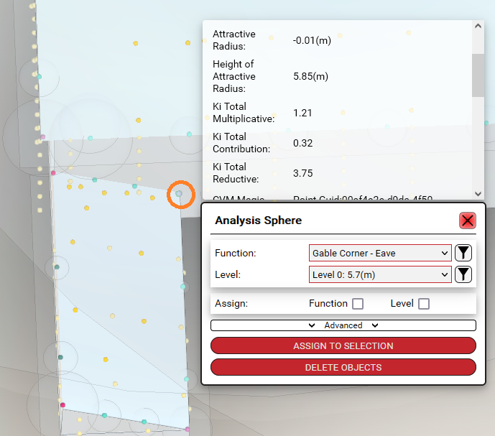

POI 2 pulls the correct slope although the height value seems strange. It should be 5.85 but is reduced to 0.149. I’m not sure if this is an issue that **@Ron** can fix?

POI 6:

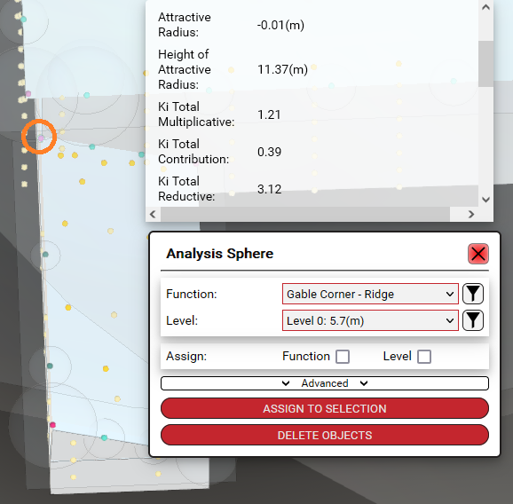

I can’t see anything wrong here… It should’ve pulled EQ F but looks like it didn’t? **@Ron Geyer**

POI 17:

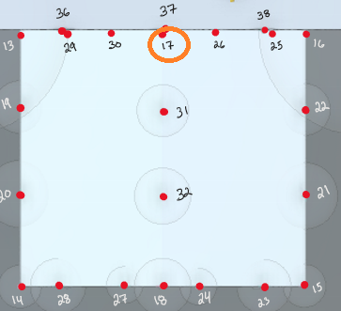

Still seems like it’s not pulling FQN **@Ron Geyer**

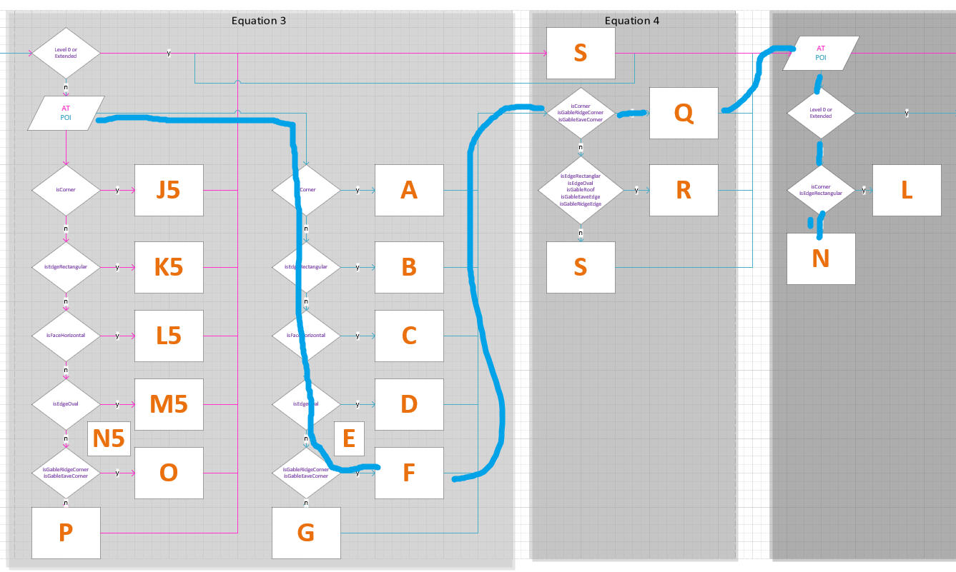

     "isCorner": false,

      "isEdgeRectangular": false,

      "isEdgeOval": false,

      "isCvmEdgePoint": false,

      "isFaceHorizontal": false,

      "isFaceVertical": false,

      "isGableEaveCorner": false,

      "isGableEaveEdge": false,

      "isGableRidgeCorner": **true**,

      "isGableRidgeEdge": false,

      "isGableRoof": false,

I’m not sure if PoiLocation.Corner pulls the Boolean for isGableRidgeCorner or isGableEaveCorner, should pull equations FQN

Slope of .587 compared to xl of .61 which is close enough

POI 25-26:

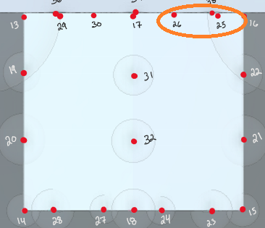

Should pull GRN **@Ron Geyer**

**POI25:** 786d5658-0491-4e6d-af5c-3c9cb2f9281b

**POI26:**

I’m not sure if isGableRoof is considered in the above case statements, should pull equation G

POI 29-30:

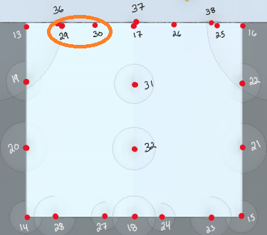

Should pull GRN **@Ron Geyer**

POI29: 8de8acb9-ea3a-4fed-9c52-beb72a0f6bc0

POI30: d221ef73-e106-4e51-a9f4-29a613ecb1e5

POI 52:

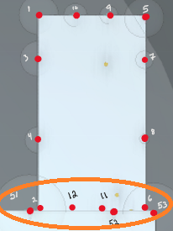

I believe slope on these should either be 0.54(ish) or 1.65 depending on limitations (if we can only assign a single slope to a level/sublevel)

Or

The slope below this is 0.774 which is likely where the slope is coming from:

**@Carlo Marsden**

POI MAP:

